
COURSE PLAN
Department : | Information and Communication Technology
Course Name & code : | Data Structures |  | ICT 2153
Semester & branch : | III Sem BTech | IT/CCE
Name of the faculty : | Dr. Balachandra
L | T | P | C
3 | 1 | 0 | 4
No of contact hours/week:

COURSE OUTCOMES (COS)
At the end of this course, the student should be able to: |  |  |  | Program Outcomes(POs) | PSO | BL
  No. of
  Contact
  Hours
  Marks
CO1 | Relate the concepts of dynamic meomory allocation, classes and analysis of performance of algorithms | 6 | 13 | 1, 2, 3, 4, 12 | 1, 2, 3 | 3, 4
CO2 | Use appropriate data structures like arrays, linked list, stacks and queues to solve real world problems efficiently. | 22 | 45 | 1, 2, 3, 4, 12 | 1, 2, 3 | 1, 2, 3, 4
CO3 | Demonstrate the working of nonlinear data structures like trees and graphs to design algorithms for various applications | 16 | 32 | 1, 2, 3, 4, 12 | 1, 2, 3 | 1, 2, 3, 4
CO4 | Illustrate various techniques for searching and sorting | 4 | 10 | 1, 2, 3, 4, 12 | 1, 2, 3 | 2, 3, 4
 | Total

COURSE LEARNING OUTCOMES (CLOS)
At the end of this course, the student should be able to: |  |  |  | Program Outcomes(POs) | Learning Outcomes (LOs) | BL
  No. of Contact Hours
  Marks
CLO1 | Relate the concepts of dynamic meomory allocation, classes and analysis of performance of algorithms | 6 | 13 | 1, 2, 3, 4, 12 | 1, 3, 12 | 3, 4
CLO2 | Use appropriate data structures like arrays, linked list, stacks and queues to solve real world problems efficiently. | 22 | 45 | 1, 2, 3, 4, 12 | 1, 2, 3, 5, 12 | 1, 2, 3, 4
CLO3 | Demonstrate the working of nonlinear data structures like trees and graphs to design algorithms for various applications | 16 | 32 | 1, 2, 3, 4, 12 | 1, 2, 3, 5, 12 | 1, 2, 3, 4
CLO4 | Illustrate various techniques for searching and sorting | 4 | 10 | 1, 2, 3, 4, 12 | 1, 5, 12 | 2, 3, 4
 | Total | 48 | 100

Assessment Plan
IN – SEMESTER ASSESSMENTS
S. No. | Assessment Mode |  | Assessment Method | Time Duration | Marks | Weightage | Typology of Questions | Schedule | Topics Covered
1 | MISAC | 1 | In-semester Exam 1 | 60 Mins | 15 | Objective: 5M  10 MCQs × ½ = 5 marks  Descriptive: 10 M  (2 Questions of 2 marks +2 Questions of 3 marks) | Bloom’s taxonomy (BT) level of the question should be L3 and above. | September 24 – 30, 2022 | L1-L14, T1-T4
1 | MISAC | 2 | Surprise Assignment | 20 Mins | 5 | 1 Question × 5M = 5 marks  (Minimum 5 questions to be given) | Bloom’s taxonomy (BT) level of the question should be L3 and above. | October 03 – October 08, 2022 | L1-L15, T1-T5
1 | MISAC | 3 | Quiz | 15 Mins | 5 | 10 MCQs × ½ = 5 | Bloom’s taxonomy (BT) level of the question should be L3 and above. | October 10 – 14, 2022 | L6-L15, T1-T5
1 | MISAC | 4 | In-semester Exam 2 | 60 Mins | 15 | Objective: 5M  10 MCQs × ½ = 5 marks  Descriptive: 10 M  (2 Questions of 2 marks +2 Questions of 3 marks) | Bloom’s taxonomy (BT) level of the question should be L3 and above. | November 09 – November 15, 2022 | L16-L30, T6-T10
2 | FISAC | 1 | Quiz | 15 mins | 5 | 10 MCQs × ½ = 5 | Bloom’s taxonomy (BT) level of the question should be L3 and above. | October 3 – 8, 2022 | L1-L15, T1-T5
2 | FISAC | 2 | Surprise Assignment | 20 Mins | 5 | 1 Question × 5M = 5 marks  (Minimum 5 questions to be given) | Bloom’s taxonomy (BT) level of the question should be L3 and above. | October 31 – November 5, 2022 | L1-L27, T1-8
END – SEMESTER ASSESSMENT

1 | Regular/Make–Up Exam |  |  | 180 Mins | 50 | Answer all 5 full questions of 10 marks each. Each question can have 3 parts of 2/3/4/5/6 marks. | Bloom’s taxonomy (BT) level of the question should be L3 and above. | 17th week of the semester | Comprehensive examination covering full syllabus.

*** Individual faculty must identify the assessment method from table 3 and fill in the details.
NOTE: Information provided in the table is as per the In-semester assessment plan and schedule of V and VII semester B. Tech provided from Academic Section.
Flexible In-semester Assessment Component (FISAC):

Table 3: Flexible In-semester Assessment Component (FISAC)
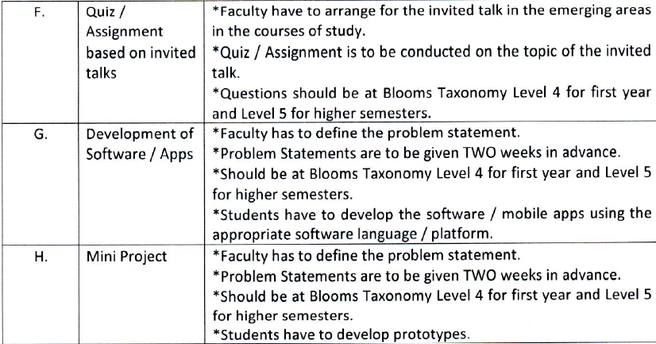

LESSON PLAN
L No | TOPICS
  Course Outcome Addressed
1 | Introduction to data structures | CO1
2 | Arrays,Functions,Searching | CO1, CO4
3 | Insertion sort bubble sort,selection sort | CO1
T1 | Programs on above topics | CO1
4 | Classes and objects | CO1
5 | ADT-Abstract Data Types Performance analysis and measurement | CO1
6 | Stacks | CO2
T2 | Programs on above topics | CO2
7 | Evaluation of Arithmetic expressions | CO2
8 | Conversion of Arithmetic expressions | CO2
9 | Recursion,Multiple stacks | CO2
T3 | Programs on above topics | CO2
10 | Linear Queues | CO2
11 | Circular Queue and applications | CO2
12 | Sparse matrix introduction | CO2
T4 | Problems on above topics | CO2
13 | Sparse Transpose techniques | CO2
14 | Pointers and dynamic memory allocation | CO2
15 | Singly linked list operations | CO2
T5 | Problems on above related topics | CO2
16 | Polynomial Representation | CO2
17 | Polynomial operation using singly linked list | CO2
18 | Doubly linked lists | CO2
T6 | Problems on linked lists | CO2
19 | Dynamically linked stacks and queues | CO2
20 | Circular lists | CO2
21 | Linked list applications | CO2
T7 | Problems on linked lists | CO2
22 | Review of linked lists | CO2
23 | Tree Terminologies | CO3
24 | Binary tree | CO3
T8 | Strictly binary tree,complete binary trees, problems | CO3
25 | Memory representation of binary tree | CO3
26 | Tree traversals recursive | CO3
27 | Tree traversals non recursive | CO3
T9 | Problems on trees | CO3
28 | Expression trees | CO3
29 | Binary Search trees,decision trees | CO3
30 | Applications of Binary tree | CO3
T10 | Problems such as copying ,checking for binary tree equality | CO3
31 | Threaded binary trees,Heaps | CO3
32 | Heaps | CO3
33 | Graphs, Depth First Search, Breadth First Search | CO3
T11 | Problems-Connected components and spanning trees | CO3
34 | Quick Sort,Merge sort | CO4
35 | Heap Sort | CO4
36 | Radix sort | CO4
T12 | Review problems | CO3, CO4

Course Articulation Matrix
CO | PO1 | PO2 | PO3 | PO4 | PO5 | PO6 | PO7 | PO8 | PO 9 | PO 10 | PO 11 | PO 12 | PSO1 | PSO2 | PSO3
CO1 | 3 | 2 | 1 | 1 |  |  |  |  |  |  |  | 1 | 2 | 3 | 2
CO2 | 3 | 2 | 2 | 2 |  |  |  |  |  |  |  | 1 | 2 | 3 | 2
CO3 | 3 | 1 | 2 | 2 |  |  |  |  |  |  |  | 1 | 2 | 3 | 2
CO4 | 3 | 1 | 1 | 1 |  |  |  |  |  |  |  | 1 | 2 | 3 | 2
Articulation Level | 3 | 2 | 2 | 2 |  |  |  |  |  |  |  | 1 | 2 | 2 | 2

FACULTY MEMBERS TEACHING THE COURSE (IF MULTIPLE SECTIONS EXIST):
FACULTY | SECTION | FACULTY | SECTION
Dr. Balachandra
Dr. Diana Olivia
Dr. Veena Maiya
Mr. Akshay K C
Mrs. Veena K M

References:

Submitted by:

(Signature of the faculty)
Date:
Approved by:

(Signature of HOD)

